Tension
Tension is similar to how tension would be on a rope – the more tense it is, the more tight it is and less room for wiggling of the line, causing little movement beyond a straight line between two points; the less tense it is, the more room it has to wiggle around between the points and more room for nonlinear movement.

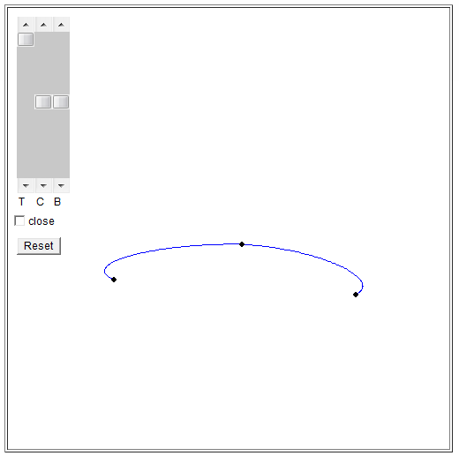

Continuity
Continuity measures how 'continuous' the line is between the points. A 0 continuity makes the line smooth and continuous as would naturally be expected. From there, it can be made less continuous by moving the lines away from the 'natural' continuous tangent either by bringing it towards a straight line between points or moving away from that point.

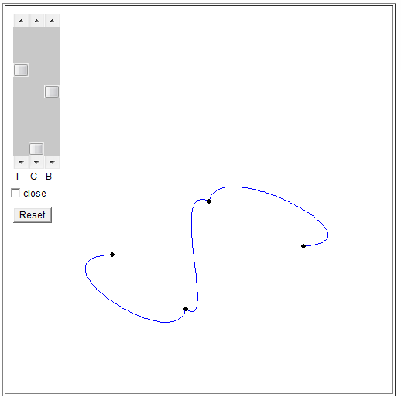

Bias
Bias is a measure of which line segment should weigh more heavily into the direction of the tangent. At a neutral bias, both line segments are considered equally towards the tangent. A bias towards one or the other line segment brings the tangent line closer to the line that lies directly between it and the previous/next point.

